

Name:Husam Ali Abdalla Nour
PRN: 25070122086
Branch: CSE (2025-29)
Semester: 3

Subject: Programming with Java

ASSIGNMENT No.: 3
TITLE: :Develop a Java application demonstrating method overloading and the use of static variables, methods in class design.

Problem Statement:
Develop a Java application demonstrating method overloading and the use of static variables, methods in class design.

Learning Objectives:

To implement method overloading and use static variables and methods in Java programs.

Theory:

Method overloading allows multiple methods to have the same name with different parameter lists, enabling compile-time polymorphism. The static keyword is used for variables and methods that belong to the class instead of individual objects. Static members share common data among all objects and reduce memory usage. These concepts improve code flexibility, readability, and efficient resource management.
Outcomes:
Java automatically selects the correct method version based on the arguments passed during the call, enabling compile-time polymorphism.

public class JAVA_EXP_3 {
static void display(int a) {
System.out.println("Integer value: " + a); }
static void display(String a) {
System.out.println("String value: " + a); }
static void display(int a, int b) {
System.out.println("Two integers: " + a + ", " + b);
}
public static void main(String[] args) { display(10); display("Hello"); display(5, 15);
}
}

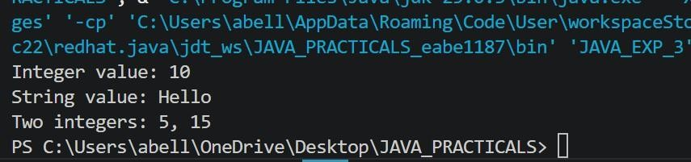

Conclusion:

This assignment demonstrates how method overloading enables compile-time polymorphism by allowing multiple methods with the same name but different parameters. It also shows how static variables and methods belong to the class, enabling shared data and efficient memory usage in Java.
Exercise:

- Develop a Calculator program using overloaded methods for addition of integers and decimals. Use a static variable to count calculations.

public class JAVA_EXP_3 { static int calculationCount = 0;
int add(int a, int b) { calculationCount++; return a + b;
}
double add(double a, double b) { calculationCount++; return a + b;
}
int add(int a, int b, int c) { calculationCount++; return a + b + c;
}
public static void main(String[] args) { JAVA_EXP_3 calc = new JAVA_EXP_3();

System.out.println("Sum of 5 + 10 = " + calc.add(5, 10));
System.out.println("Sum of 2.5 + 3.7 = " + calc.add(2.5, 3.7));
System.out.println("Sum of 1 + 2 + 3 = " + calc.add(1, 2, 3));

System.out.println("Total calculations performed: " +
JAVA_EXP_3.calculationCount); }
}

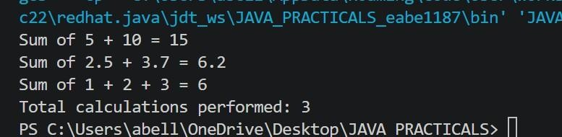
- Develop a Restaurant Billing Application where overloaded methods calculate bills for dine-in, takeaway, and delivery orders, while static variables track total orders.

public class JAVA_EXP_3{
static int totalOrders = 0; static double totalRevenue = 0;
private void updateStats(double bill){ totalOrders++; totalRevenue += bill;
}
double calculateBill(double amount){ double bill = amount + (amount * 0.05); updateStats(bill); return bill;
}
double calculateBill(double amount, double packagingCharge){ double bill = amount + packagingCharge; updateStats(bill); return bill;
}
double calculateBill(double amount, double deliveryCharge, double distanceKm) { double bill = amount + deliveryCharge + (distanceKm * 10); updateStats(bill); return bill;
}
public static void main(String[] args){ JAVA_EXP_3 rb = new JAVA_EXP_3();
double dineInBill = rb.calculateBill(500);
System.out.println("Dine-in Bill: " + dineInBill);
double takeawayBill = rb.calculateBill(300, 20); System.out.println("Takeaway Bill: " + takeawayBill);
double deliveryBill = rb.calculateBill(400, 30, 5);
System.out.println("Delivery Bill: " + deliveryBill);
System.out.println("Total Orders: " + JAVA_EXP_3.totalOrders);
System.out.println("Total Revenue: " + JAVA_EXP_3.totalRevenue);
}
}
